2022 PRA Summer Events
May 28th – PRA Camp with Rugby ATL – Boys only camp that gives athletes a chance to be selected with Rugby ATL u18s and the Panther Rugby Academy at the RAN u19 with January 1, 2003 birthdate. It’s only $50 and ALL players must register with Rugby ATL to participate.
https://shop.rugbyatl.rugby/collections/rugby-experiences/products/pathway-404-u18-talent-identification-camp-may-28th-2022

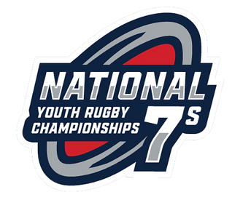
June 10-12 : Panther Rugby Academy supports Rugby ATL's Academy U18 side to play NOLA, Houston & Austin's U18 academies. All details and costs managed thru Rugby ATL. You must participate in the May 28th ID camp to be considered for this event. https://shop.rugbyatl.rugby/collections/rugby-experiences/products/pathway-404-u18-talent-identification-camp-may-28th-2022
June 10-12 : U14 National 7s Youth Rugby Championships – (2) U14 Boys & (1) Girls Teams in Cleveland, OH
June 14-23 : England & Wales Summer Tour
Panther Rugby Academy is taking Girls HS; Boys u16s, u18s and U23 Men’s Teams. Trip includes (3) Rugby Practices with Professional Coaches and play in (3) Rugby Games and Tour to major sites as we travel to London, Bath and Cardiff. https://form.jotform.com/PantherRugbyAcademy/england-wales-rugby-tour-2022
July 14 – 17 Rugby Americas North (RAN) U19 Men The Panther Rugby Academy will compete in this World Rugby Competition in Kingston, Jamaica at University of the West Indies. Players born after January 1, 2003 are elgible and will require valid Passport. Attend Camp on May 28th at Rugby ATL Camp to be selected by PRA Coaches. https://rugbyamericasnorth.com/jamaica-to-host-2022-ran-senior-womens-12s-and-mens-under-19/
July 22-23 : NAI 7s – TBD U18, U16, U14 Boys and Girls - Salt Lake City, UT
August 27-28, : Los Angeles Invitational - World Rugby and USA Rugby leg of the HSBC World Rugby Sevens Series, the LA Sevens, set to take place March 5- 6, 2022 at Dignity Health Sports Park in Carson, Calif.

